3.4 Test for different Screen Size
TC-3.4.1 – Desktop Screen – Full HD (1920 × 1080)
Tester | Anil KC
Browser & Version | Google Chrome 136 | Desktop – Linux
Device / Screen | Desktop / Laptop (1920 × 1080 px)
Test Objective | Verify that the Moonlight WMS application renders correctly on a full HD desktop display. All UI elements – sidebar navigation, stat cards, charts, tables, and forms – must be fully visible, properly aligned, and functional without horizontal scrolling.

Steps Taken
Step | Action
1 | Open Google Chrome on a desktop/laptop computer.
2 | Navigate to moonlight.defencexinso.com.
3 | Verify the Login page: logo, heading, email/password fields, "Sign in as Employee" button, and social login options are all correctly positioned.
4 | Log in as Employee. Verify the Dashboard: full sidebar is expanded, stat cards (Total Products, Low/Out of Stock, Active Suppliers, Inventory Value) are displayed in a 4-column row, and the Weekly Sales Volume chart is visible.
5 | Navigate to Catalogue > Categories. Verify the category grid renders in multiple columns with category cards, product counts, and Active badges.
6 | Log out and log in as Admin. Verify the Admin Dashboard shows user management widgets, pending approvals, users-by-role chart, and failed login alerts.
7 | Log out and log in as Manager. Verify the Manager Dashboard shows correct stat cards with 0-values for a fresh/empty site and the chart area renders without errors.
8 | Confirm no horizontal scroll bar appears on any page at full HD resolution.

Result | All five pages (Login, Employee Dashboard, Categories, Admin Dashboard, Manager Dashboard) rendered correctly at 1920 × 1080. The full sidebar remained expanded and readable, stat cards displayed in proper 4-column layout, charts loaded without errors, and the category grid used a multi-column responsive grid. No horizontal scrolling was observed.
Pass / Fail | PASS

Screenshot Evidence
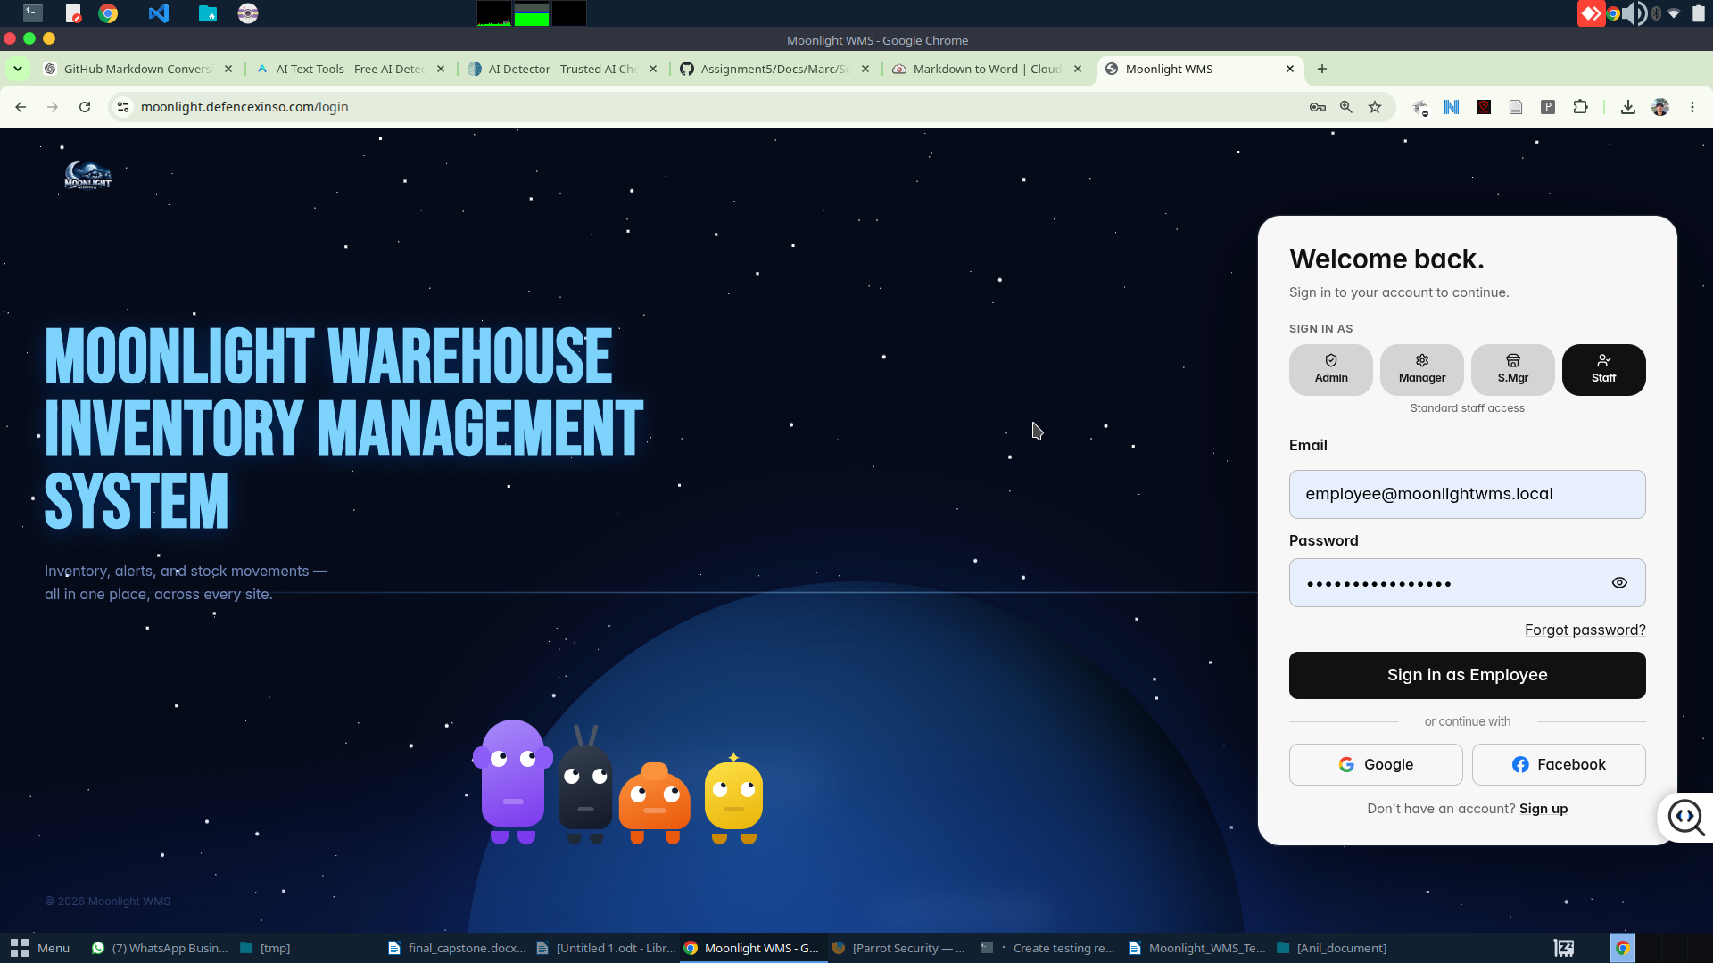
Figure 1 – Desktop: Login Page (moonlight.defencexinso.com/login)

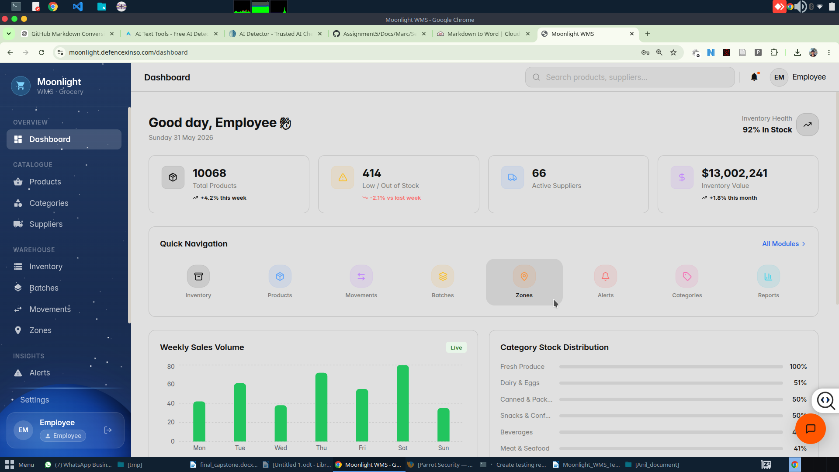
Figure 2 – Desktop: Employee Dashboard

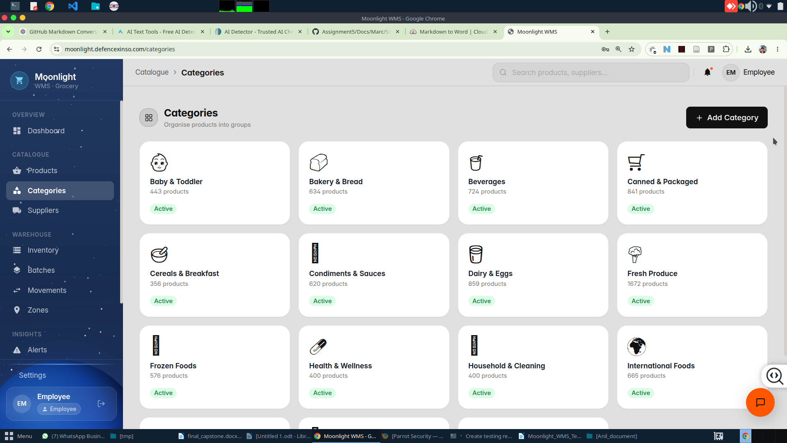
Figure 3 – Desktop: Catalogue › Categories

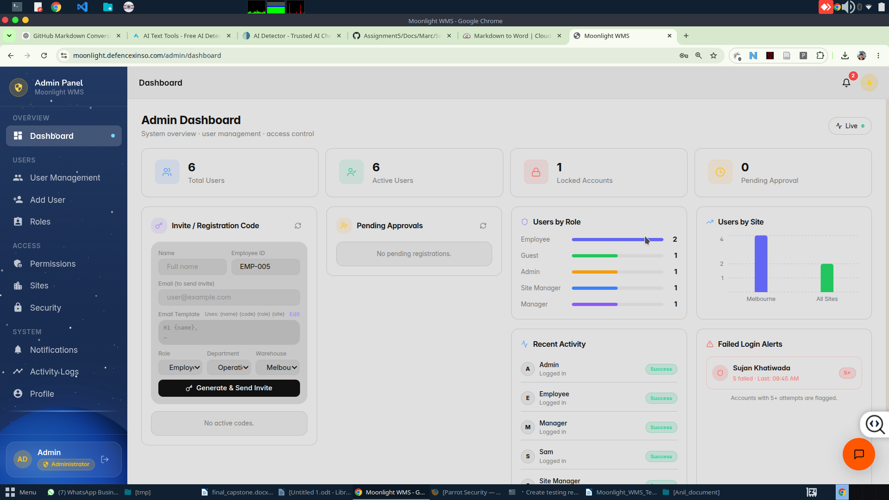
Figure 4 – Desktop: Admin Dashboard

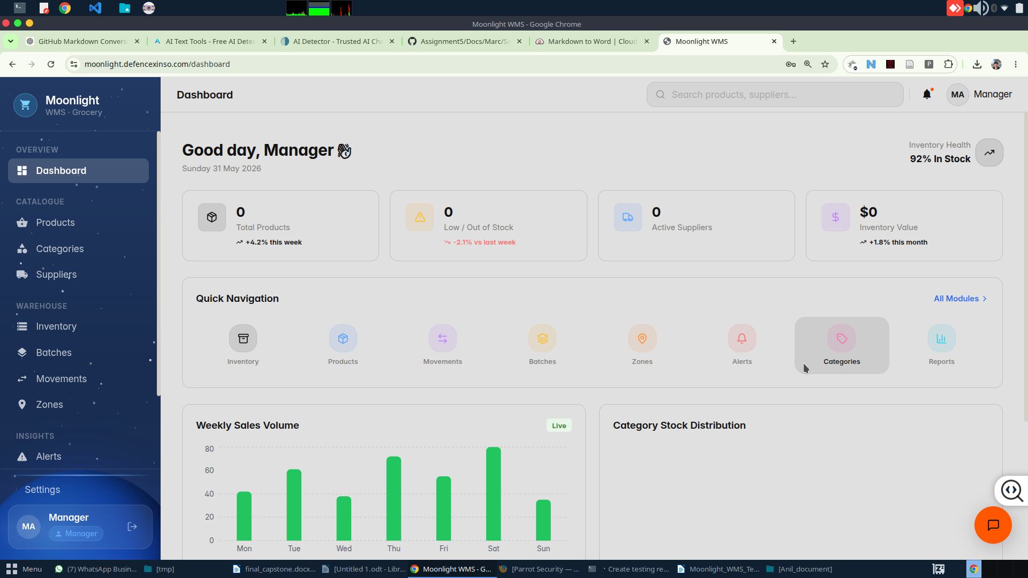
Figure 5 – Desktop: Manager Dashboard

TC-3.4.2 – Tablet Screen – iPad (~768 × 1024 px)
Tester | Anil KC
Browser & Version | Safari / Chrome for iOS | iPad (approx. 768 × 1024 px)
Device / Screen | Apple iPad (portrait mode, ~768 px viewport width)
Test Objective | Verify that the Moonlight WMS application adapts its layout for a tablet-sized viewport. The sidebar must remain visible and functional, two-column form layouts must be maintained, data tables must be readable, and interactive widgets (e.g., AI chat assistant) must overlay without disrupting the page layout.

Steps Taken
Step | Action
1 | Open Safari (or Chrome) on an iPad device.
2 | Navigate to moonlight.defencexinso.com and log in as Employee.
3 | Navigate to Account > Settings. Verify the Profile form displays in a two-column layout (Display Name / Email, Phone / Department, Site / Role) with the sidebar visible.
4 | Navigate to Catalogue > Products. Verify the product listing table is fully visible with columns (Product, Category, Barcode, Cost, Price) and the "+ Add Product" button is accessible. Confirm the sidebar is expanded and readable.
5 | Return to Settings. Tap the chat button (orange FAB) to open the Moonlight Assistant widget. Verify the chat panel overlays without breaking the background layout.
6 | Navigate to Insights > Reports. Verify charts (Stock Movement Trend, Inventory Value by Category) and downloadable report cards render correctly with the sidebar visible.

Result | The application adapted correctly to tablet viewport. The sidebar remained visible and expanded in a collapsible rail on the left. Form fields maintained a two-column layout. The Products table displayed all columns with horizontal scroll available. The Moonlight Assistant chat overlay appeared correctly over the Settings page. The Reports page rendered both charts and download cards without layout issues.
Pass / Fail | PASS

Screenshot Evidence
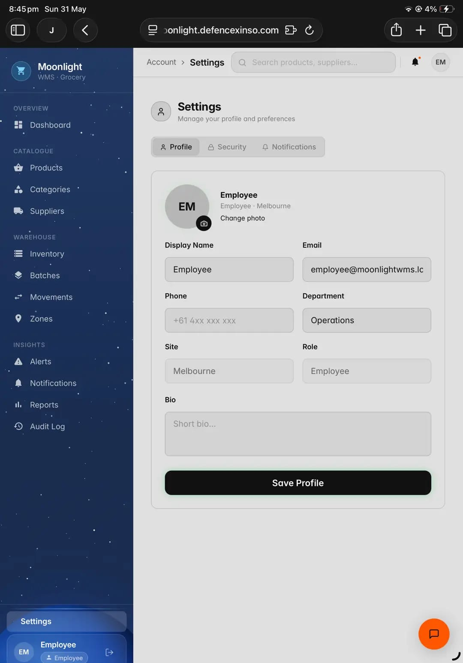
Figure 6 – Tablet: Settings › Profile (sidebar visible)

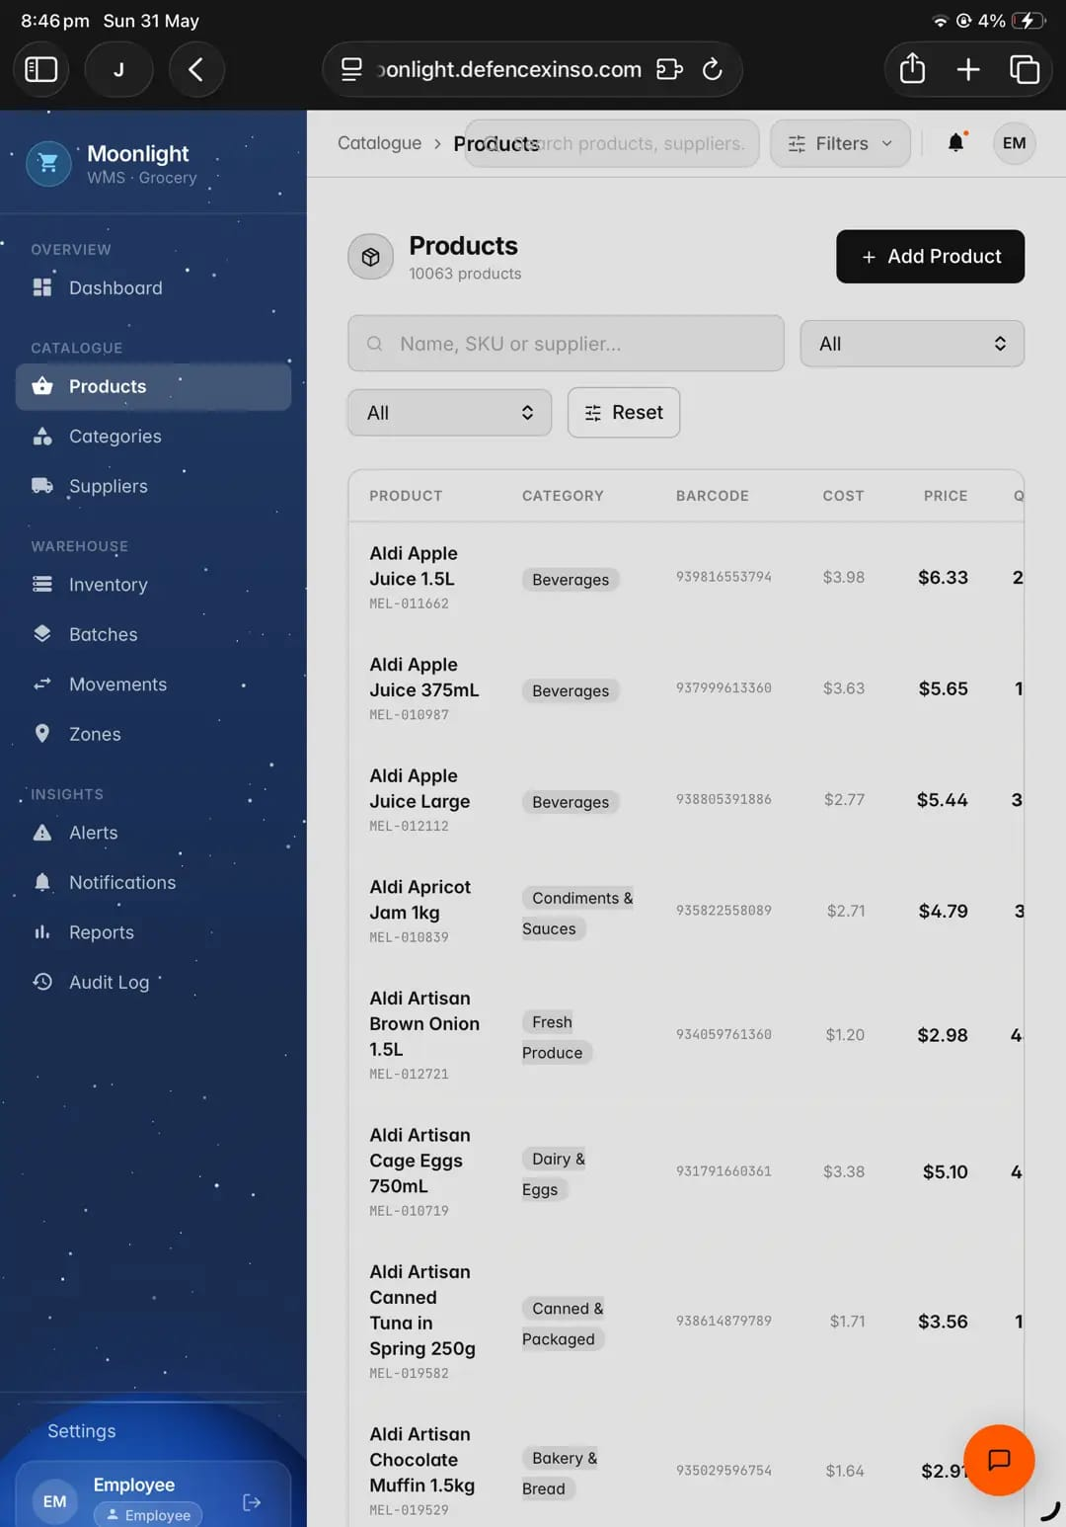
Figure 7 – Tablet: Catalogue › Products listing

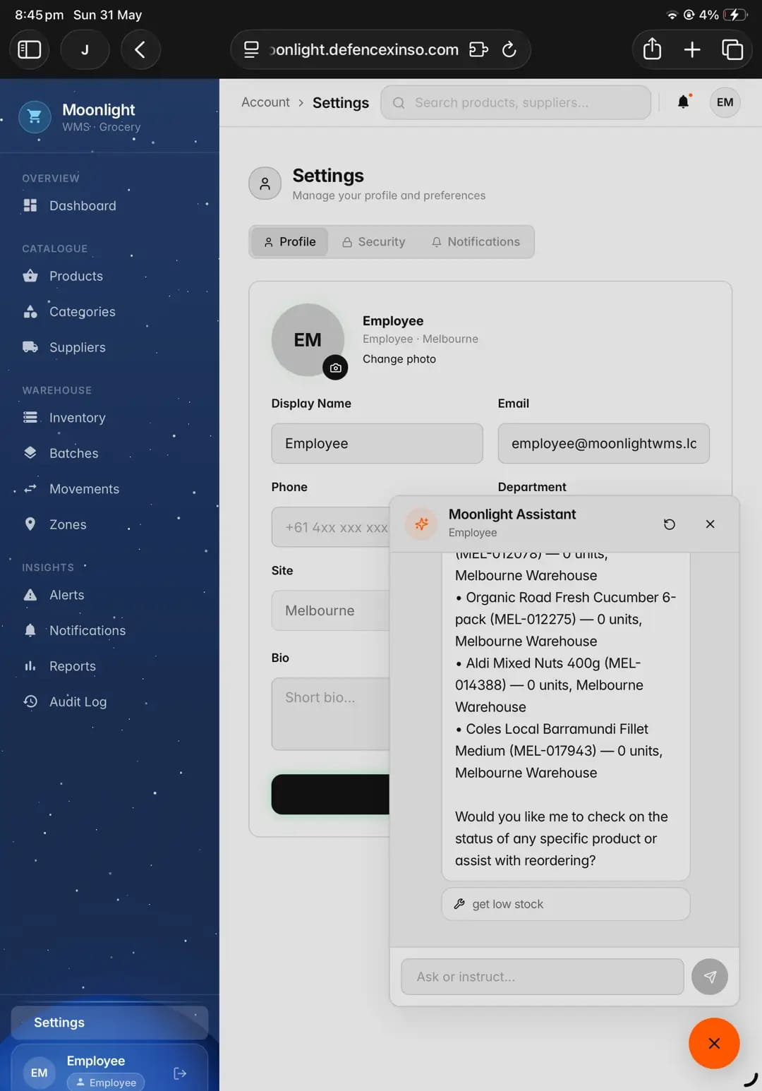
Figure 8 – Tablet: Settings with Moonlight Assistant chat overlay

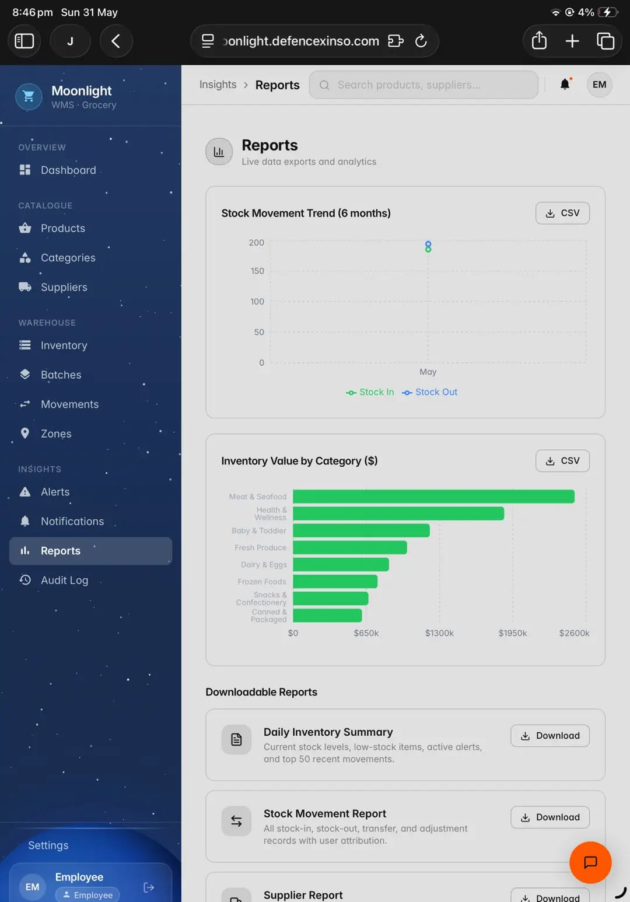
Figure 9 – Tablet: Insights › Reports (charts + downloadable reports)

TC-3.4.3 – Mobile Screen – Android Phone (~390 × 844 px)
Tester | Anil KC
Browser & Version | Google Chrome for Android | Android Phone (~390 px viewport width)
Device / Screen | Android Smartphone (portrait mode, ~390 px viewport width)
Test Objective | Verify that the Moonlight WMS application is fully functional and readable on a mobile phone screen. Navigation must collapse to a bottom tab bar, content must stack vertically, tables must be horizontally scrollable, and all key features must remain accessible via touch-friendly controls.

Steps Taken
Step | Action
1 | Open Chrome on an Android mobile device.
2 | Navigate to moonlight.defencexinso.com and log in as Employee.
3 | Verify the Employee Dashboard: hamburger menu icon top-left, stat cards stack in 2-column grid, bottom navigation bar (Dashboard, Inventory, Movements, Alerts, More) is visible, and the Quick Navigation module icons are accessible.
4 | Navigate to Account > Settings (via hamburger or More menu). Verify the Profile form is displayed in a single-column stacked layout with all fields visible.
5 | Navigate to Activity Logs (Admin role or via More menu). Verify the log table shows Dest IP, Device, Log Type, and Status columns with horizontal scroll. Confirm the "CSV" and "Splunk" export buttons are accessible.
6 | Log out and log in as Admin. Navigate to Admin Dashboard. Verify the stat cards (Total Users, Active Users, Locked Accounts, Pending Approval), the Invite/Registration Code widget, and the "Generate & Send Invite" button are all accessible on mobile.

Result | The application correctly adapted to mobile viewport. The sidebar was replaced by a bottom navigation tab bar. Stat cards stacked in a 2-column grid. The Settings form collapsed to single-column. The Activity Logs table was horizontally scrollable with all columns accessible. The Admin Dashboard stat cards and Invite Code widget stacked cleanly. All features remained functional via touch controls.
Pass / Fail | PASS

Screenshot Evidence
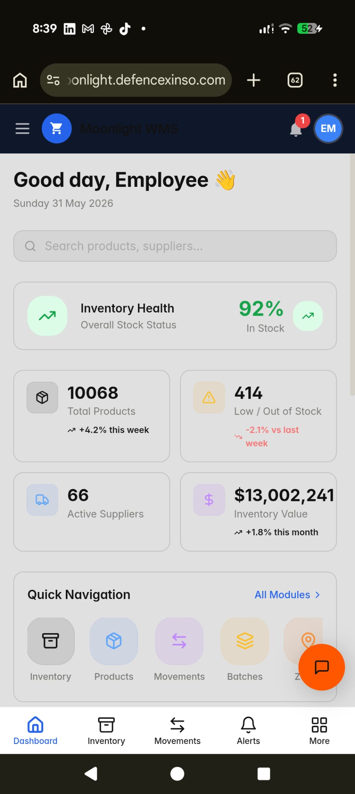
Figure 10 – Mobile: Employee Dashboard (bottom nav bar, stacked stat cards)

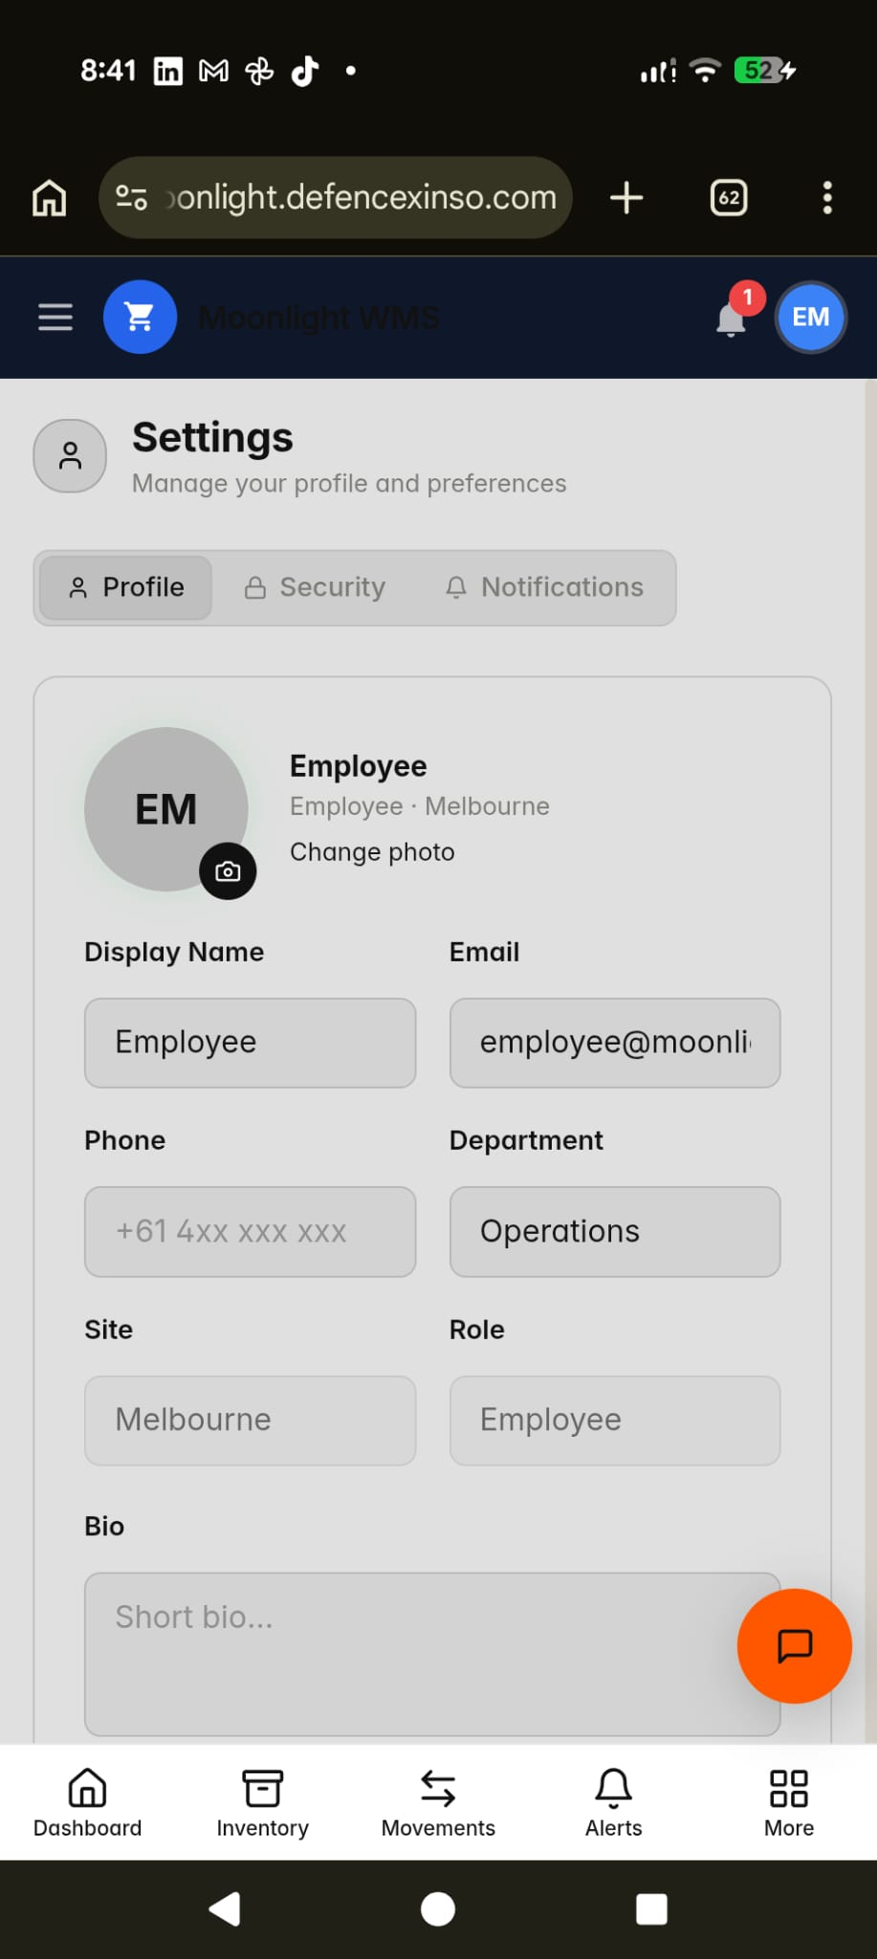
Figure 11 – Mobile: Settings › Profile (single-column stacked form)

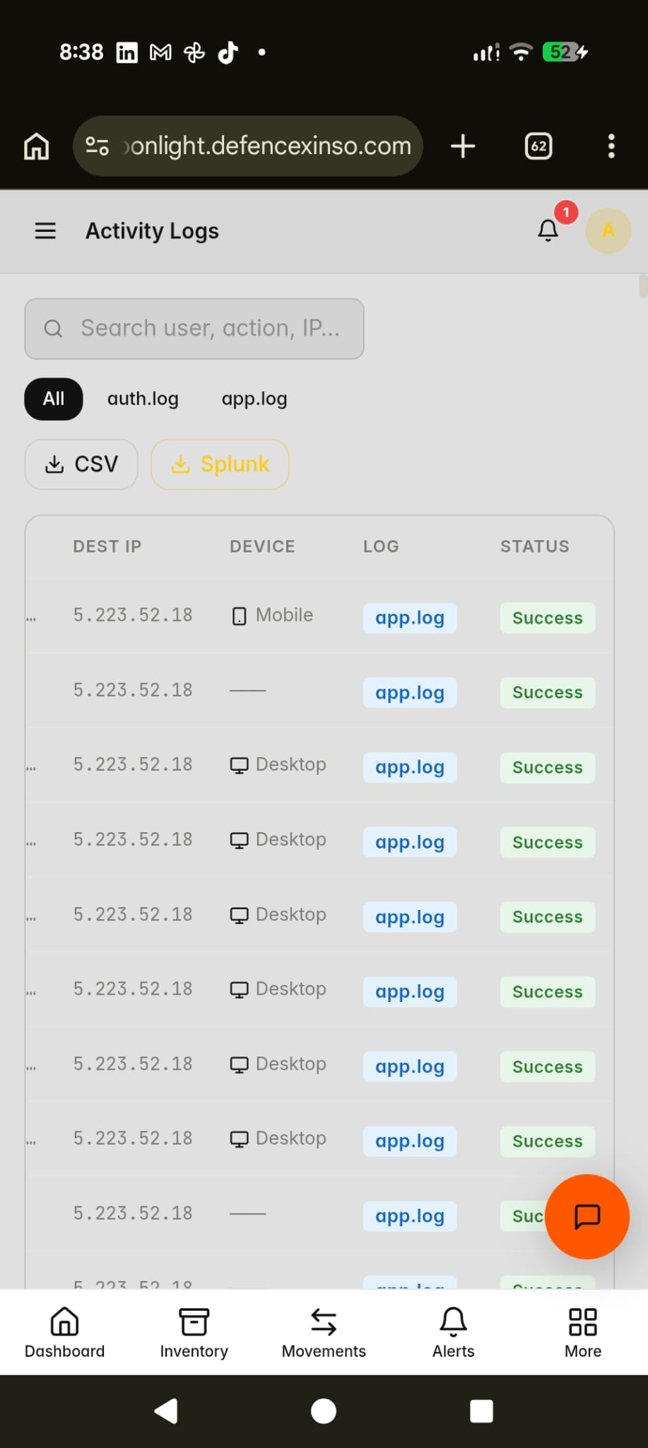
Figure 12 – Mobile: Activity Logs (scrollable table, CSV/Splunk buttons)

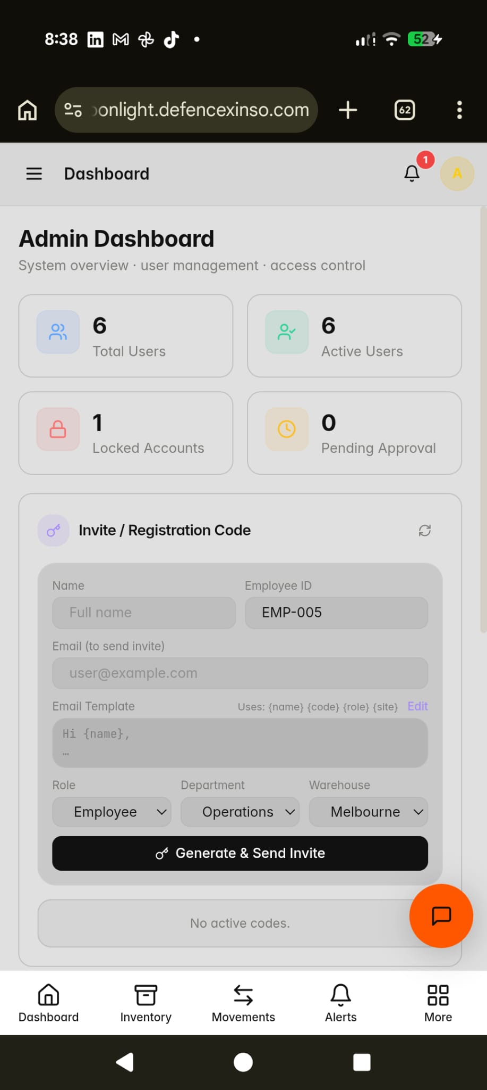
Figure 13 – Mobile: Admin Dashboard (stat cards + Invite/Registration widget)
Test Case ID | Screen Type | Device / Viewport | Browser | Pass / Fail
TC-3.4.1 | Desktop – Full HD | 1920 × 1080 px | Google Chrome 136 (Linux) | PASS
TC-3.4.2 | Tablet – iPad | ~768 × 1024 px | Safari / Chrome for iOS | PASS
TC-3.4.3 | Mobile – Android | ~390 × 844 px | Google Chrome for Android | PASS

Conclusion: All three screen size test cases passed. The Moonlight Warehouse Inventory Management System demonstrates full responsiveness across Desktop (1920 × 1080), Tablet (~768 × 1024), and Mobile (~390 × 844) viewports. Navigation adapts from an expanded sidebar (desktop), to a collapsible rail (tablet), to a bottom tab bar (mobile). Content stacks and reflows correctly at each breakpoint with no broken layouts or inaccessible features observed.

Different

